Data Visualization Lab 5
M. Umar Shafiq
BSDSF24A050
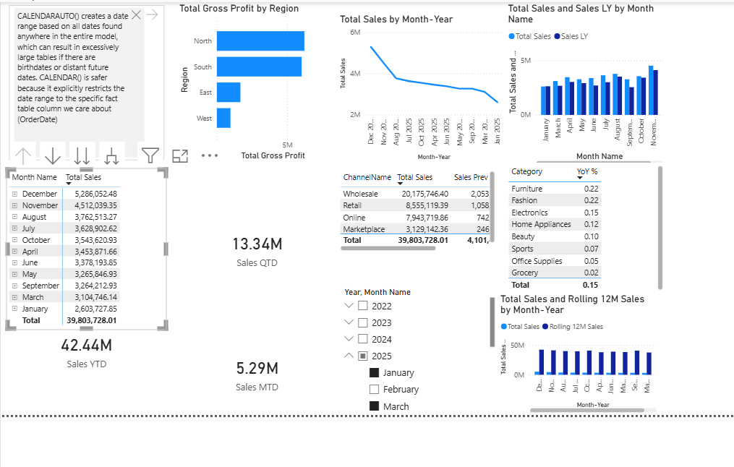
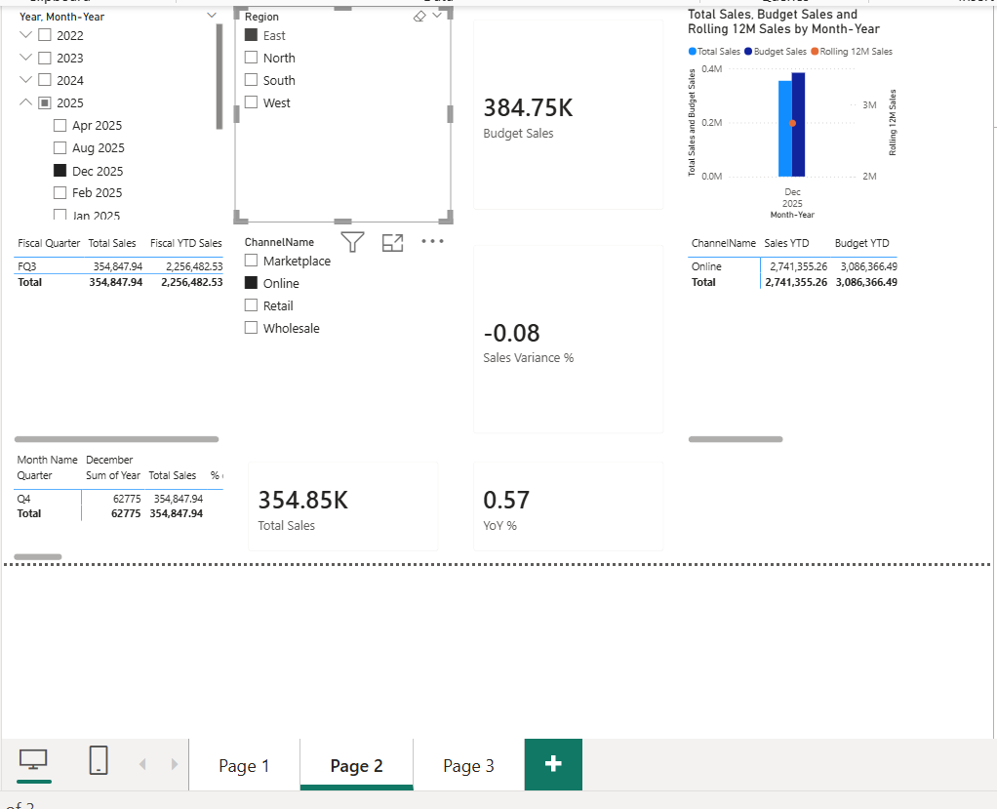
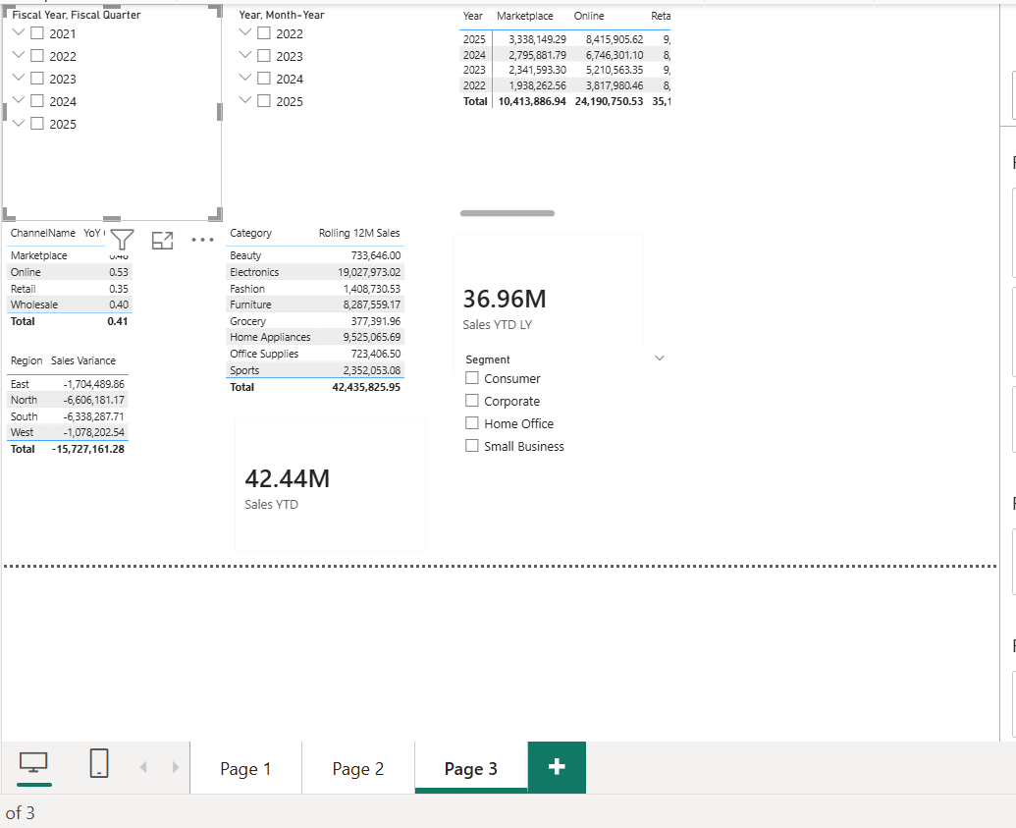

1. Long-term Growth & Seasonal Volatility
- Trend Stabilization: The 12-month rolling sales average reveals a consistent upward trajectory from 2022 to 2025. This rolling calculation effectively smooths out the intense month-to-month volatility, proving that the underlying business is growing despite seasonal dips in the late summer months.
- Fiscal Accumulation: The custom fiscal year tracking (starting in April) correctly aligns with the company’s financial reporting. Fiscal Quarter 3 (Oct-Dec) consistently accounts for the largest proportion of annual sales, driven by end-of-year holiday promotions and campaigns.

2. Year-Over-Year (YoY) Performance Shifts
- Channel Evolution: The YoY analysis matrices demonstrate a distinct shift in consumer behavior. While traditional ’Retail’ channels maintained steady volume, the ’Online’ and ’Marketplace’ fulfillment channels exhibited the highest YoY percentage growth, particularly in 2024 and 2025.
- CategoryLeaders: Consumer electronics and Home Appliances emerged as the top-performing categories by YoY growth percentage in the latest complete year, indicating highly successful product launches or promotional strategies in those sectors.

3. Budget Variance & Target Adherence
- Actual vs. Budget Performance: The comparison between actual transactional data and monthly budget targets shows that the company generally exceeded baseline targets during the first half of the dataset (2022-2023).
- Late 2025 Variances: Toward the end of 2025, specifically in the South and West regions, the model highlights distinct negative sales variances. This suggests that while sales volume remained high, the aggressive budget scenarios set by Regional Directors for Q4 2025 outpaced actual market demand

